**App.js**

import './App.css';

import EventBind from './Component/EventBind'

function App() {

  return (

    <div className="App">

      <EventBind/>

    </div>

  );

}

export default App;

**EventBind.js**

import React, {Component} from 'react'

class EventBind extends Component{

  constructor(props){

     super(props)

     this.state = {

       message: 'Hello React'

      }

    }

    clickHandler(){

        this.setState({

            message:'Welcome to React'

        })

    }

    render(){

      return(

         <div>

            <h1>{this.state.message}</h1>

            <button onClick={this.clickHandler}>click me</button>

         </div>

      )

   }

}

export default EventBind;

**Output:**

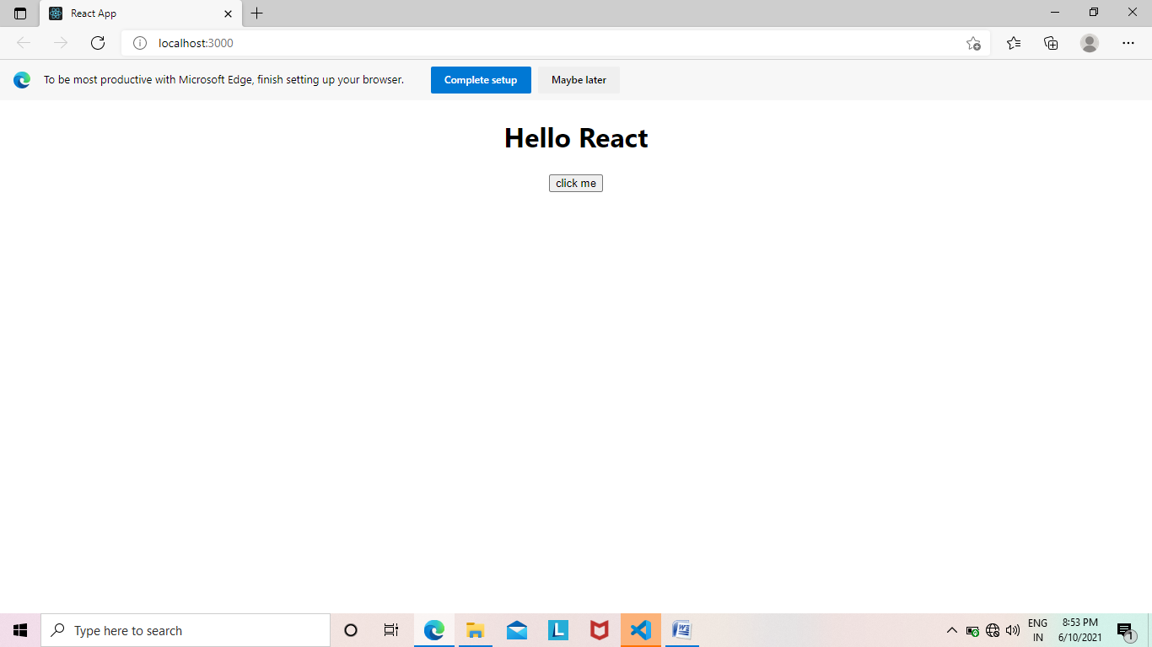

import React, {Component} from 'react'

class EventBind extends Component{

  constructor(props){

     super(props)

     this.state = {

       message: 'Hello React'

      }

    }

    clickHandler(){

        this.setState({

            message:'Welcome to React'

        })

    }

    render(){

      return(

         <div>

            <h1>{this.state.message}</h1>

            <button onClick={this.clickHandler.bind(this)}>click me</button>

         </div>

      )

   }

}

export default EventBind;

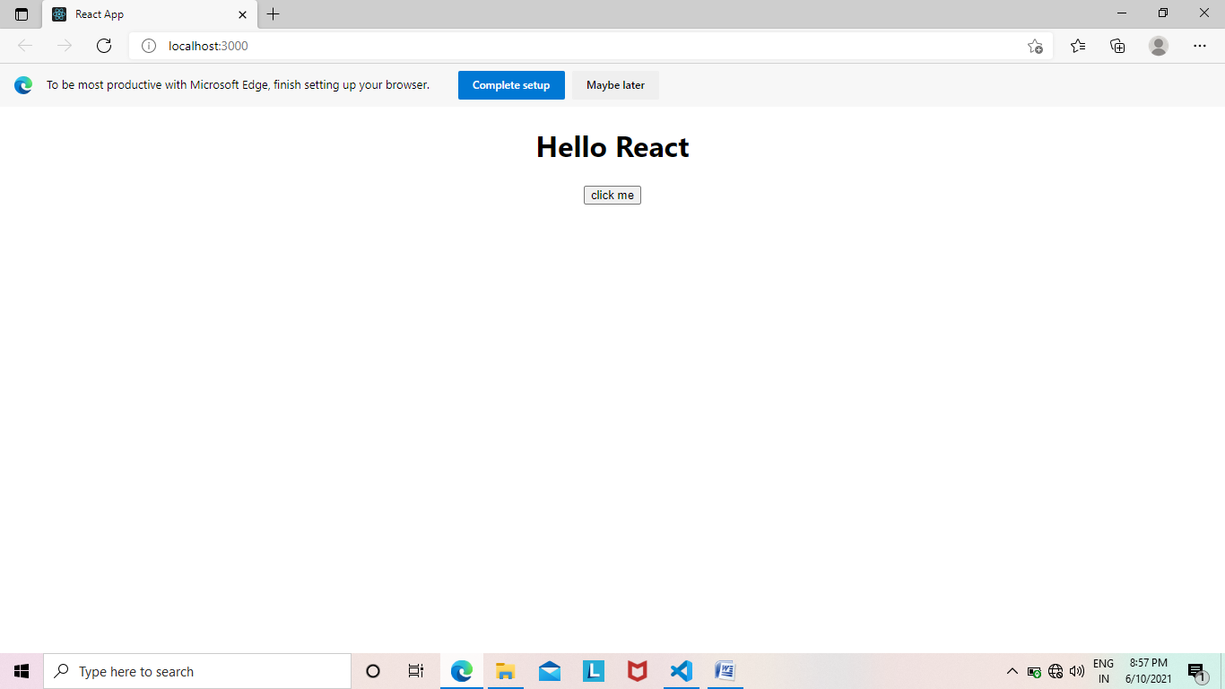

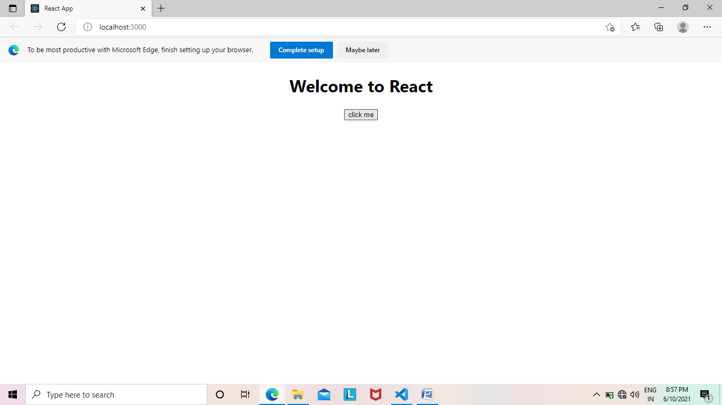

**3**

import React, {Component} from 'react'

class EventBind extends Component{

  constructor(props){

     super(props)

     this.state = {

       message: 'Hello React'

      }

    }

    clickHandler(){

        this.setState({

            message:'Welcome to React'

        })

    }

    render(){

      return(

         <div>

            <h1>{this.state.message}</h1>

            <button onClick={()=>this.clickHandler()}>click me</button>

         </div>

      )

   }

}

export default EventBind;

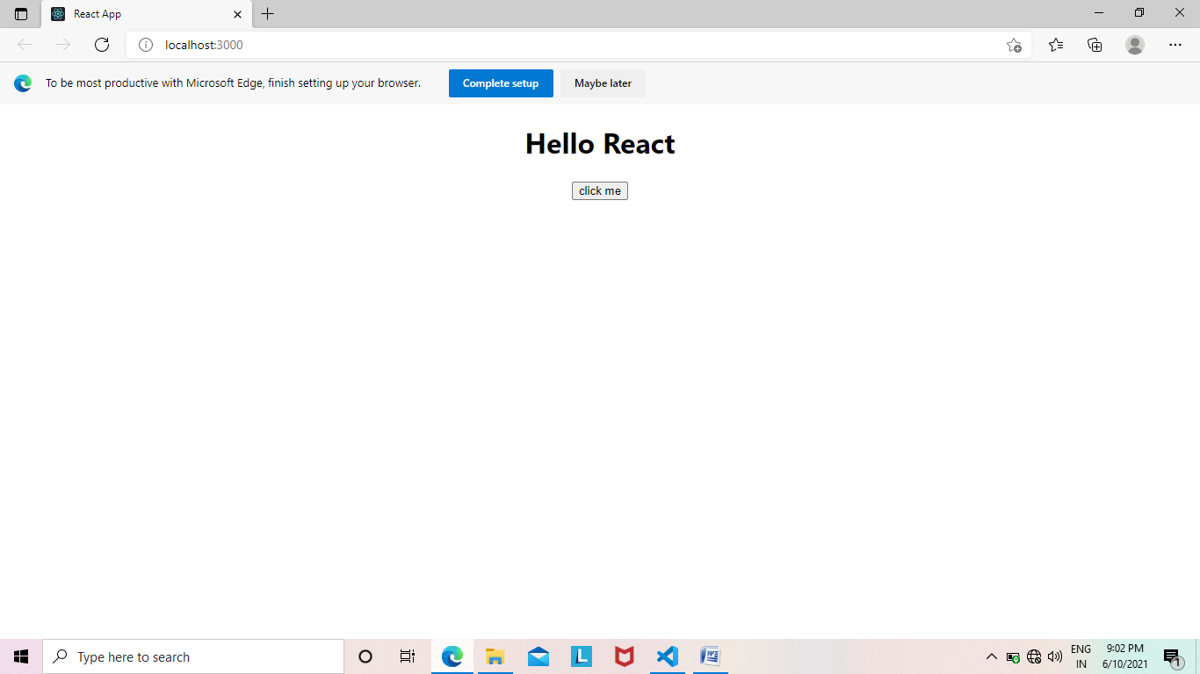

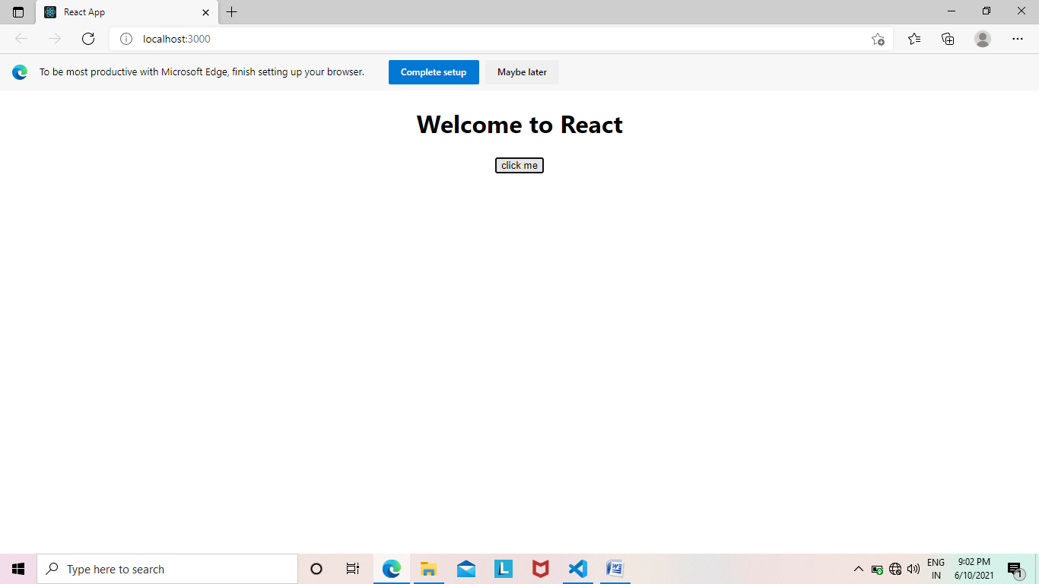

**4**

import React, {Component} from 'react'

class EventBind extends Component{

  constructor(props){

     super(props)

     this.state = {

       message: 'Hello React'

      }

    }

    clickHandler(){

        this.setState({

            message:'Welcome to React'

        },

        console.log(this.state.message))

    }

    render(){

      return(

         <div>

            <h1>{this.state.message}</h1>

            <button onClick={()=>this.clickHandler()}>click me</button>

         </div>

      )

   }

}

export default EventBind;

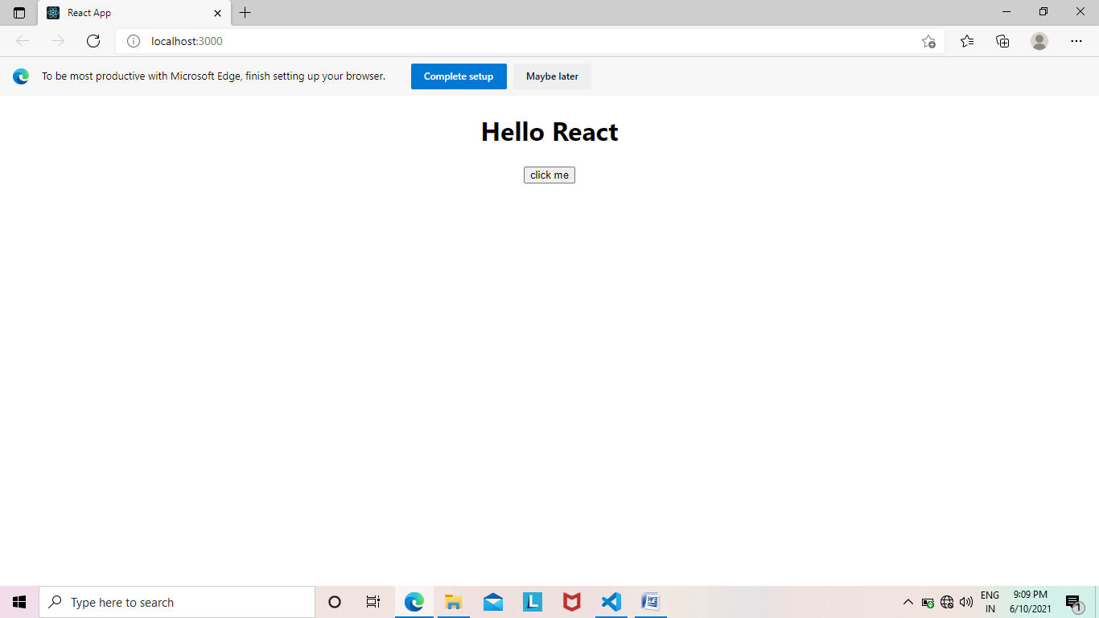



**ProductList:**

**App.js**

import './App.css';

import ProductList from './Component/ProductList'

function App() {

  return (

    <div className="App">

      <ProductList productName="Fridge" price="25000" id="1" quantity="20"/>

    </div>

  );

}

export default App;

**EmployeeDetail.js**

import React from 'react'

function EmployeeDetail({empdetail}){

    return(

        <div>

            <h1>Child component</h1>

            <h1>{empdetail.id} {empdetail.employeeName} {empdetail.age} {empdetail.skill}</h1>

        </div>

    )

}

export default EmployeeDetail;

**ProductList.js**

import React from 'react'

import EmployeeDetail from './EmployeeDetail'

function ProductList(props) {

    const empList=[

        {

            id: 1,

            employeeName: "Sravani",

            age: 20,

            skill: "C"

        },

        {

            id: 2,

            employeeName: "Sandhya",

            age: 19,

            skill: "C++"

        },

        {

            id: 3,

            employeeName: "Sravs",

            age: 20,

            skill: "React"

        }

    ]

   const productList=['Fridge', 'WashingMachine','Tiles with250MM','Table','Furniture']

   const {id,productName,price,quantity} = props

   const employeeList = empList.map(employee =>(

       <EmployeeDetail key={employee.id} empdetail={employee}/>

   ))

    return (

        <div>

            <h1>Product Details</h1>

            <h1>{id} {productName} {quantity} {price}</h1>

            {employeeList}

        </div>

    )

}

export default ProductList

